### **Manage Employees Use Cases**

1. **Manage Employees Use Case:**

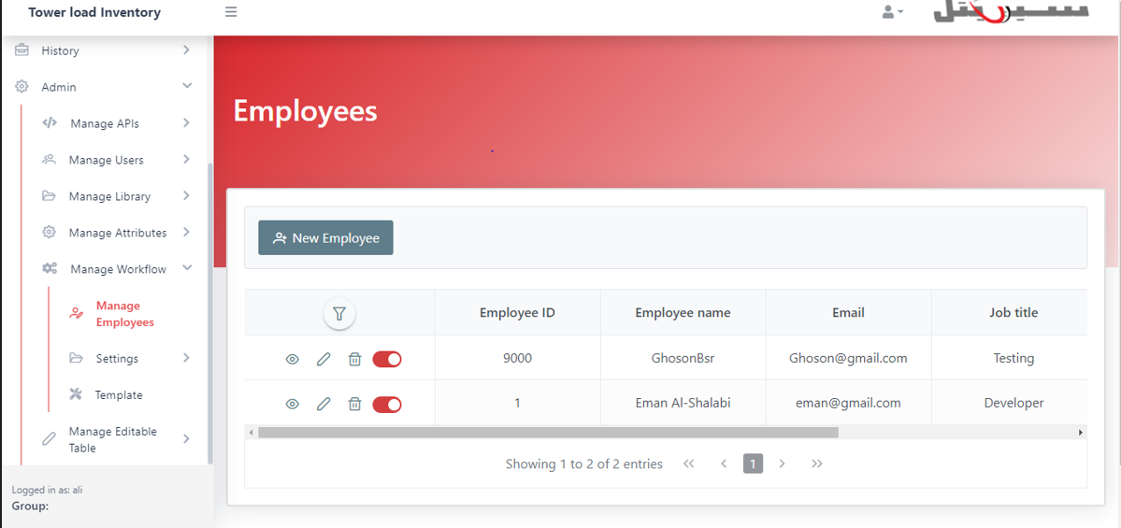

Manage Employee Interface

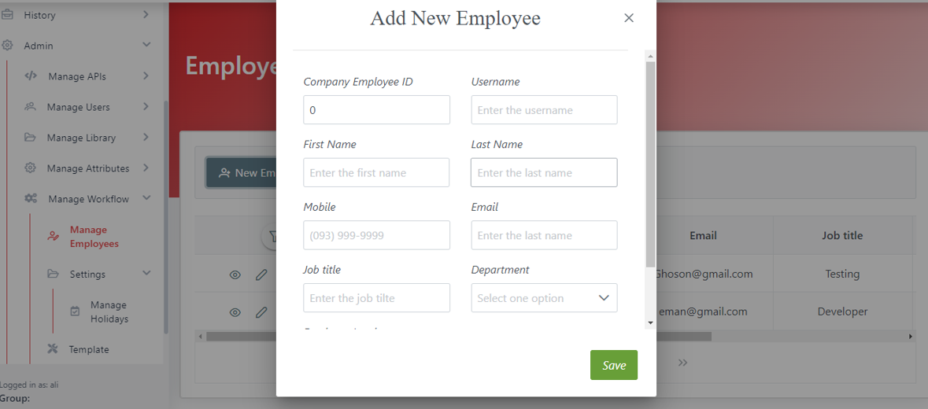

Add New Employee

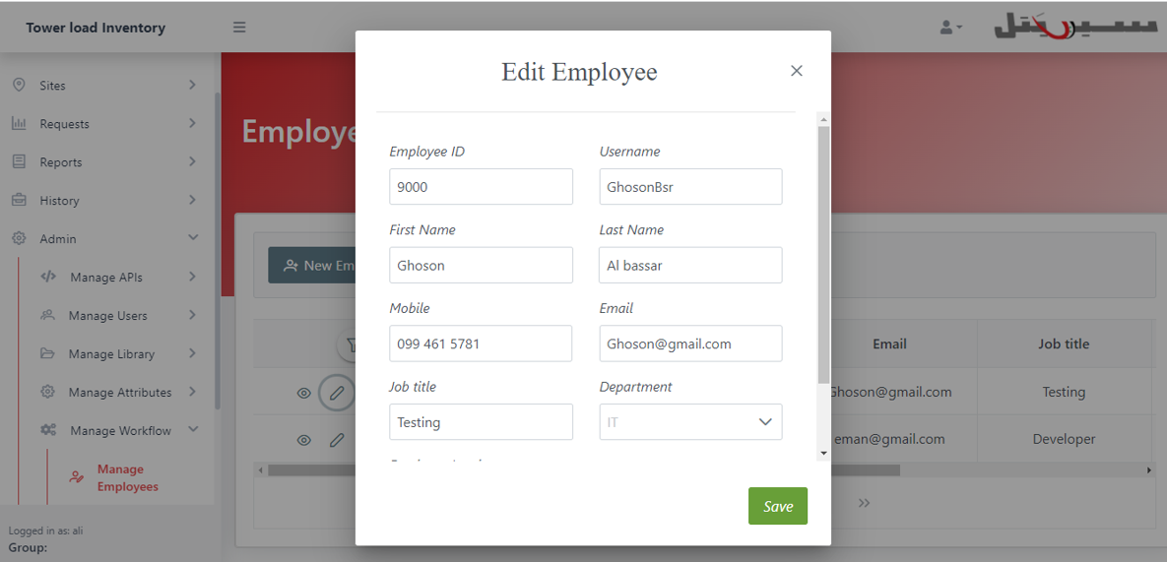

Edit Employee

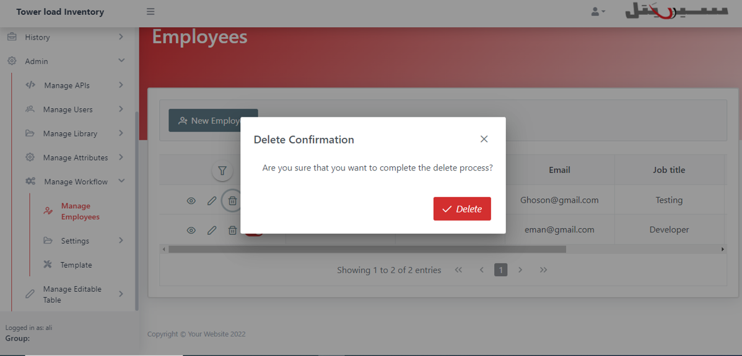

Delete Employee

### **Manage Holidays Use Cases**

1. **Manage Holidays Use Case:**

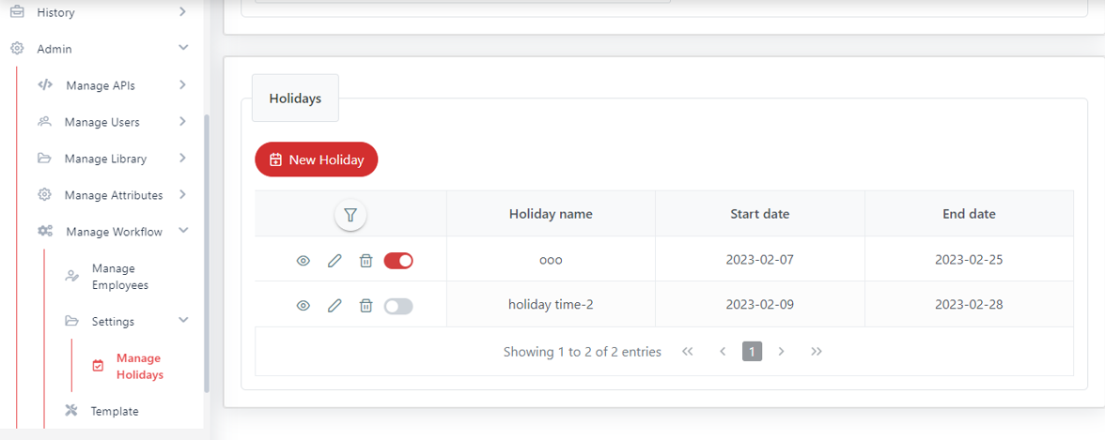

Manage Holidays Interface

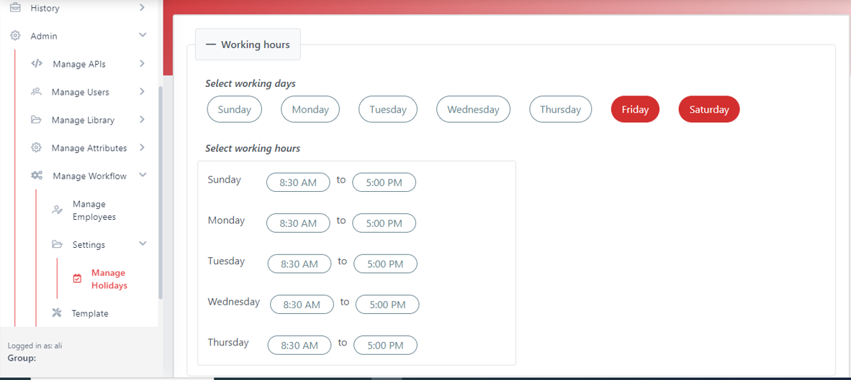

Manage Working Hours

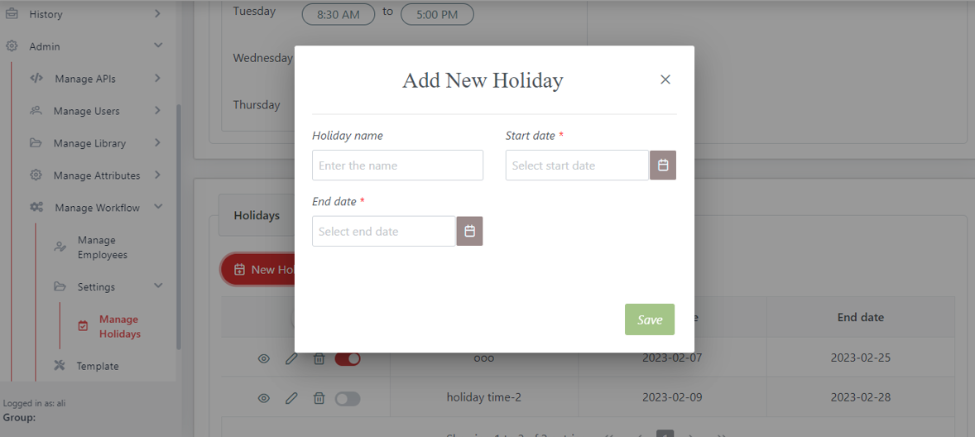

Add New Holiday

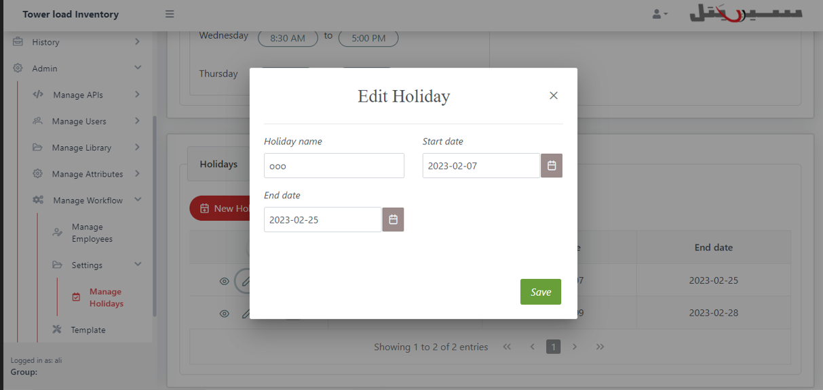

Edit Holiday

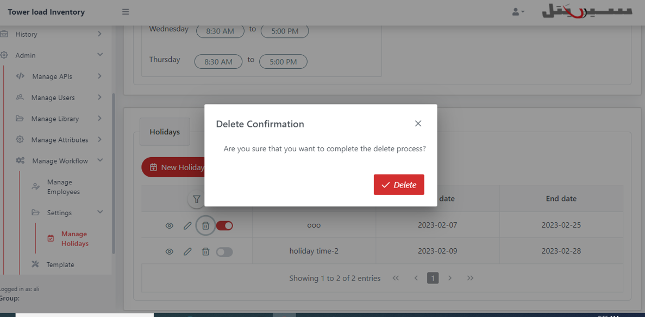

Delete Holiday

### **Workflow Template Use Cases**

#### 1. Create Workflow Template Use Case

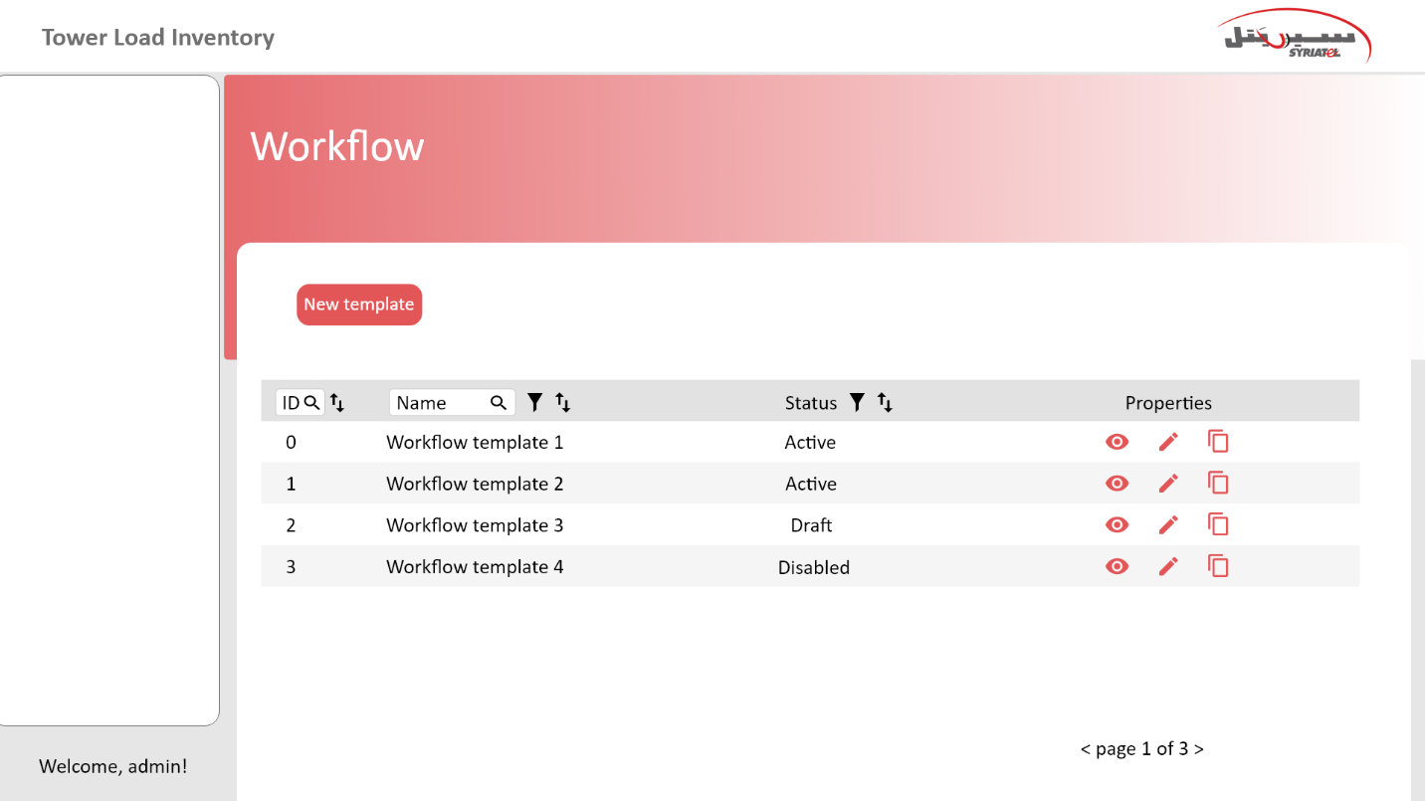

Figure 1-Button of Create Template.

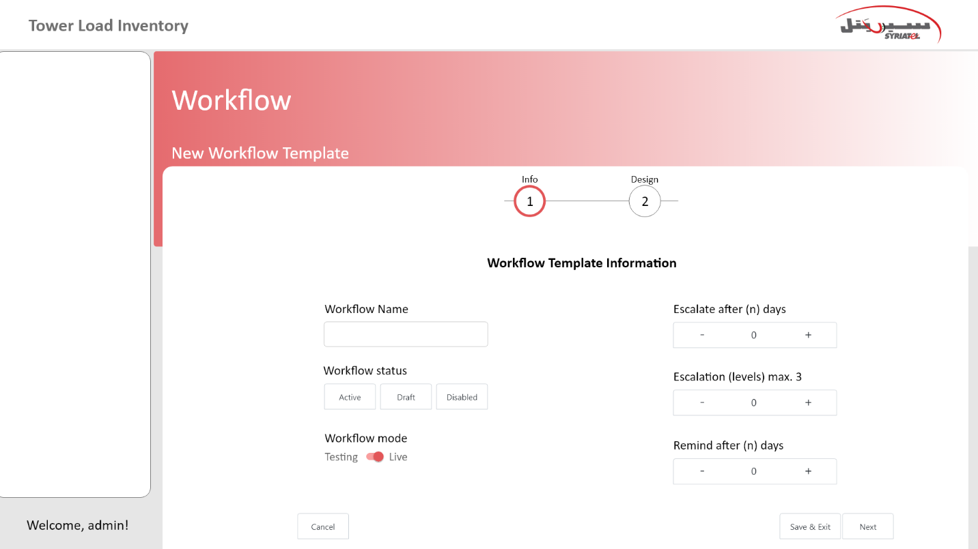

Figure 2-Adding Workflow Information.

**2. Edit Workflow Template Use Case**

Note: When clicking on the edit button, the user will be able to modify the template information When clicking on the edit button, the user will be able to modify the template information listed in the previous interface (Figure 2-Adding Workflow Information)and The user will be able to modify the order of the student within the template.

**3. Create Action Use Case**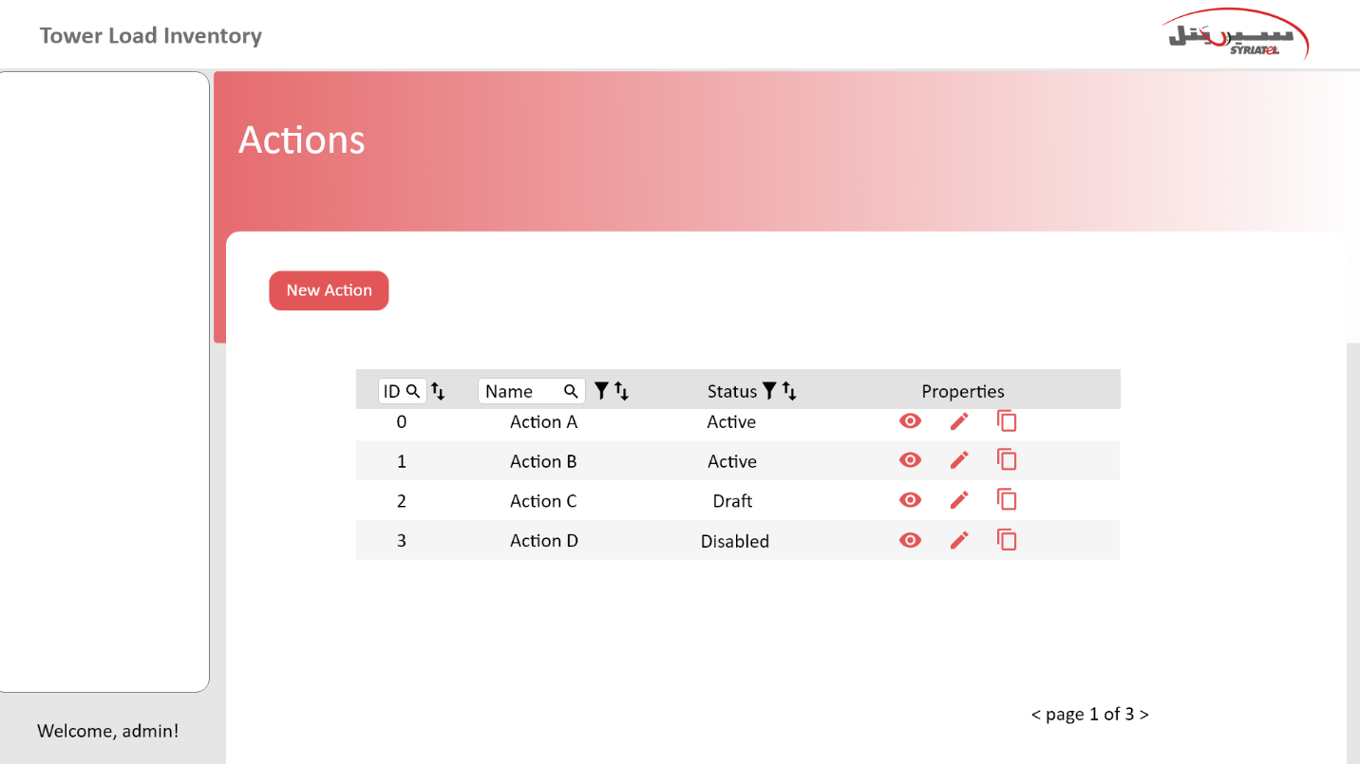

Figure 1-Button of Create Action

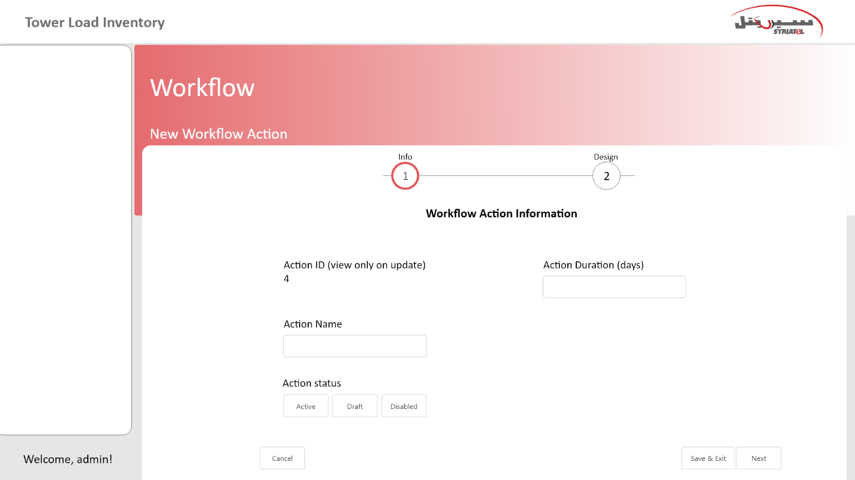.

Figure 2-Adding Action Information.

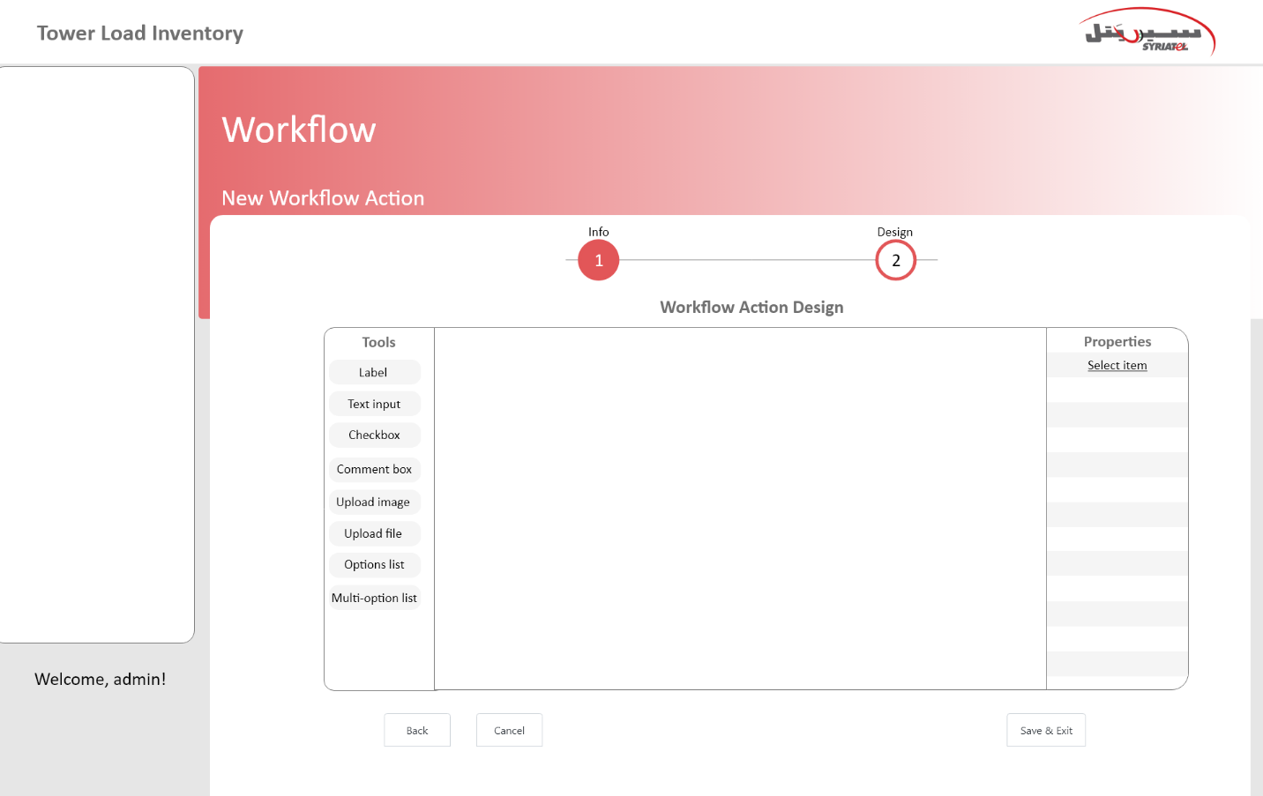

Figure 3--Button of Next

Note on the previous interface: The option will not be chosen from the group of options or multi option list, but will The option will be created with the action dynamically

#### 4. Edit Action Use Case



Figure 1- Button of Edit

Note: When pressing the edit button for the first time, the user will be able to modify the information about the action, such as the name and the time period, and after pressing the Next button, the tools interface will appear to the user so that he can modify the action design, as well as the option information, so that he can modify it as well.

#### 5. Delete Action Use Case



Figure 1- Button of Delete

Note: After pressing the delete button, an interface will appear (Are you sure you want to complete the deletion process)

#### Create Order Action Use Case

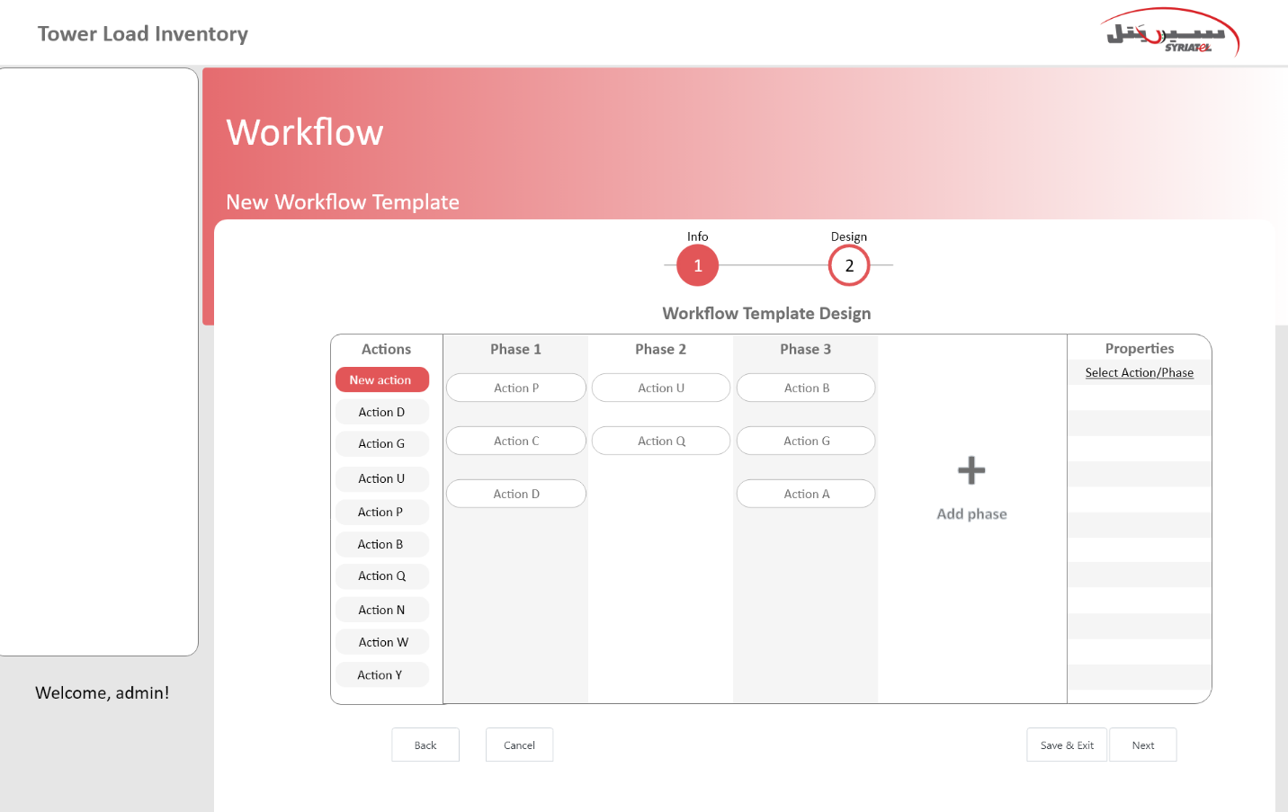

Note: The user will be able to enter the stage name

Note: When choosing an action, the action comes with its own optionsو and we will be able to choose with action options or its own set of options

Note: When creating the visa and selecting the action, we will have a list of conditions, and if the user wants to add a condition to the action that he wants to add to the stage, he chooses the condition or a group of conditions from the list of ready conditions

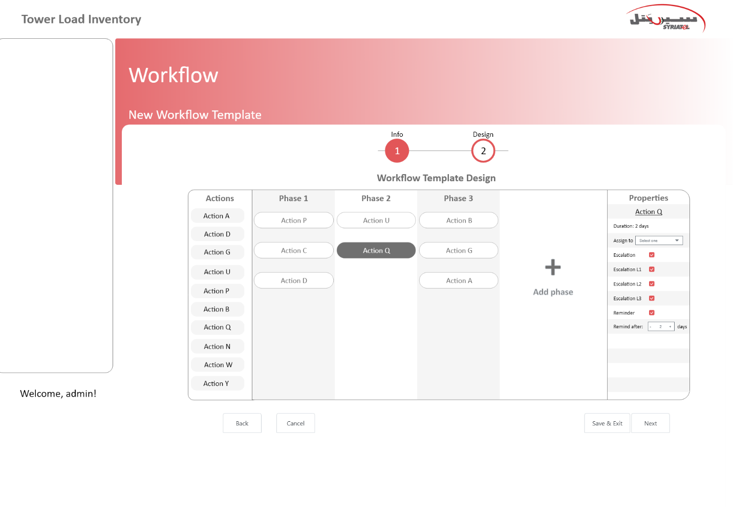 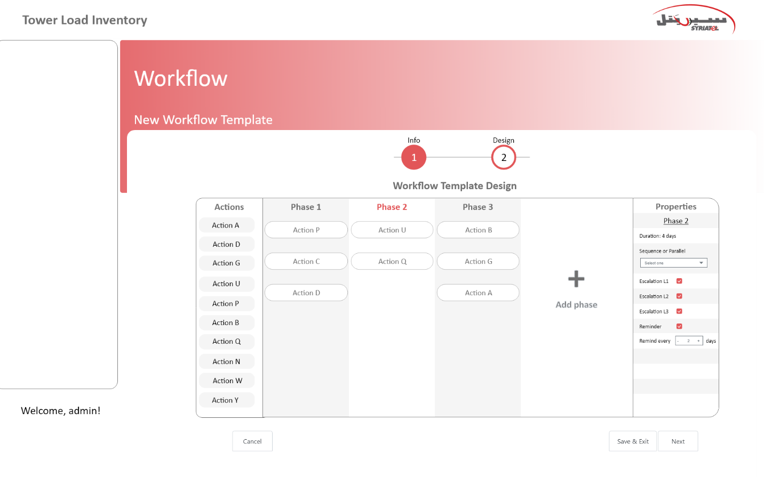

#### Copy Workflow Use Case

User wants to take a copy of workflow template to reuse it in TLIS after updating its properties

Figure 1-Button of Copy Workflow.

Note: After pressing the Copy button, an interface will appear to enter the name of the new template

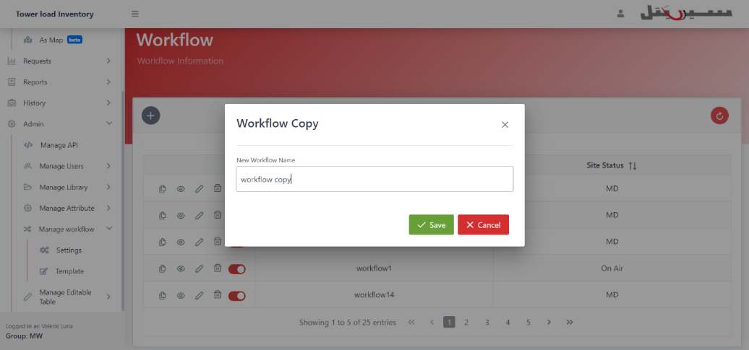

### **Mail Template Use Case**

#### Create Mail Template Use Case

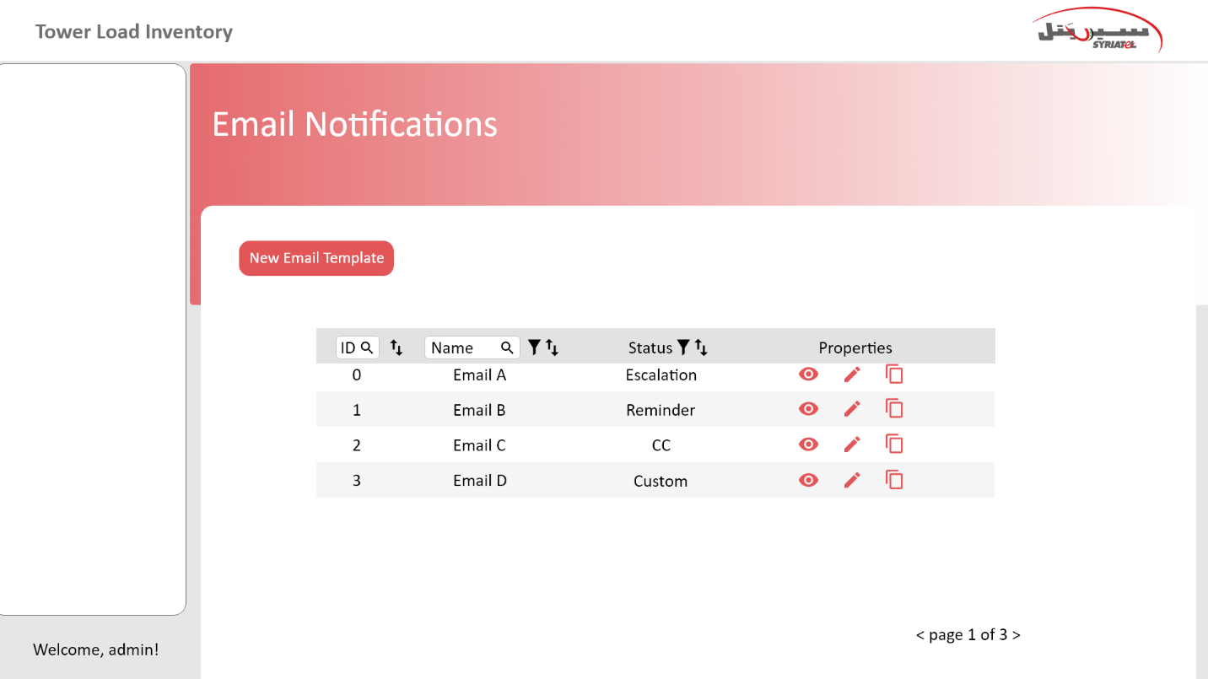

Figure 1-Button of Create Mail Template.

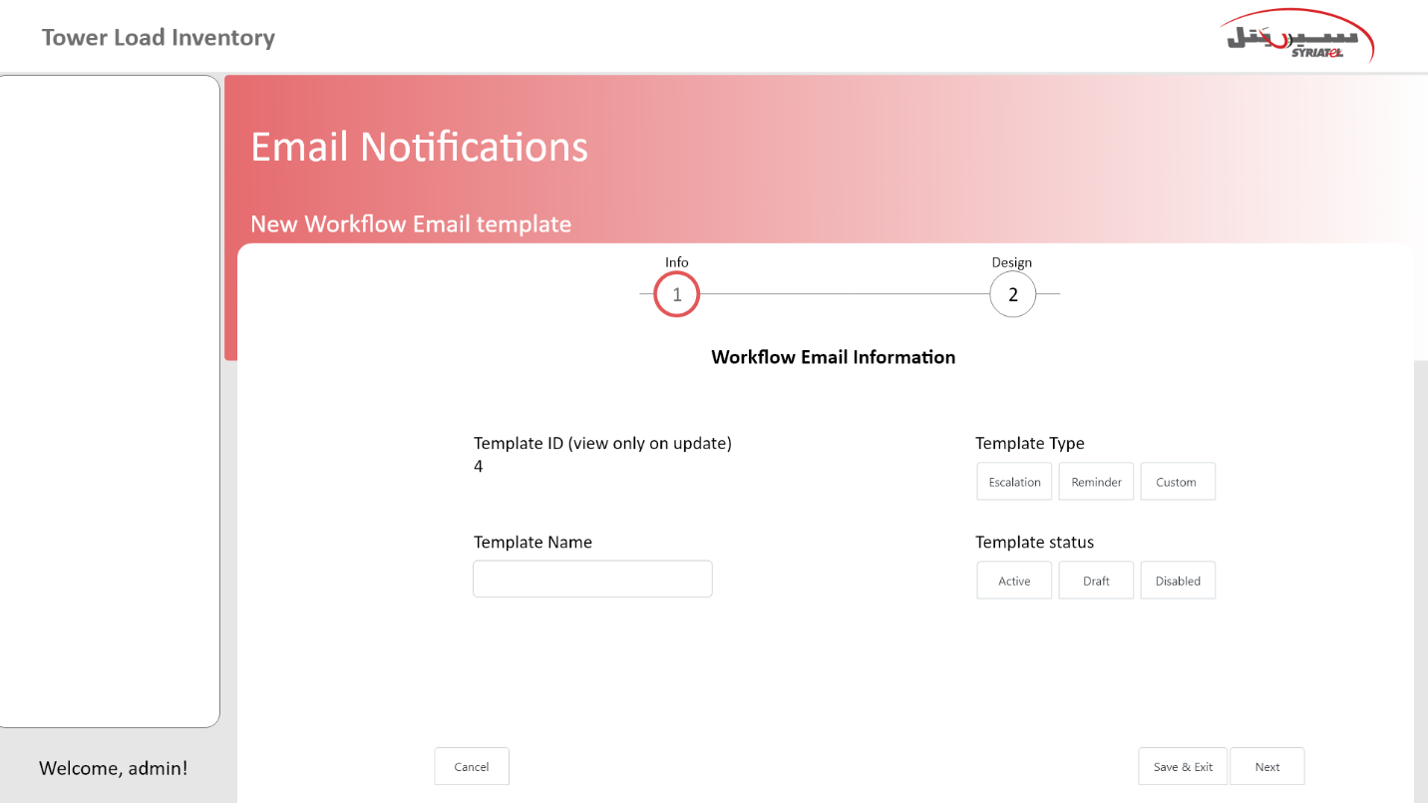

Figure 2-Adding Mail Template Information.

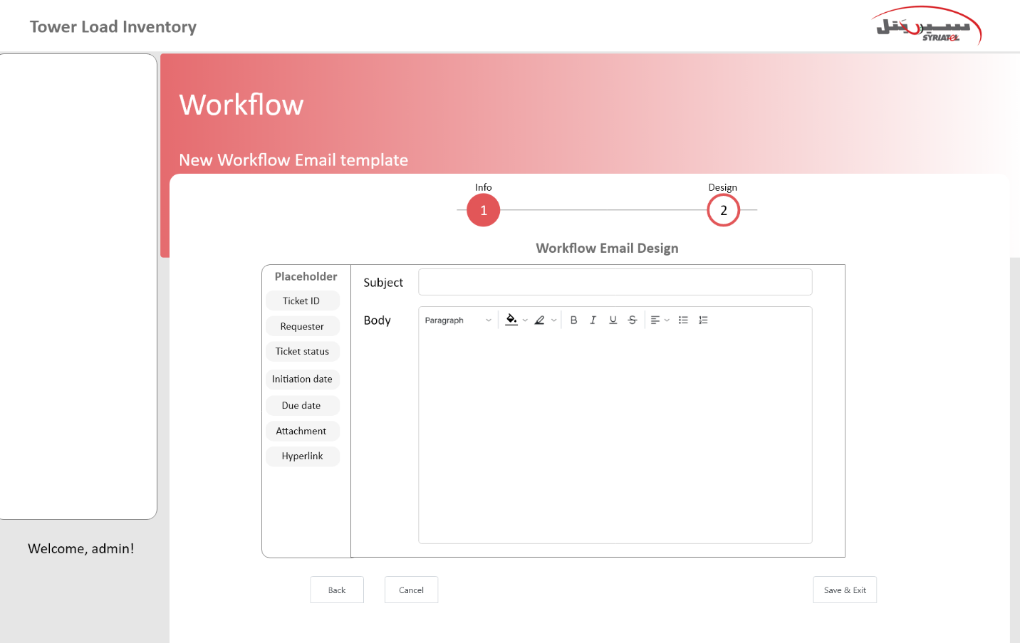

#### Add Content Use Case

Note: We have two types of content in body and subject (static and variable)

When choosing a variable type, the variable will be selected from a set of pre-existing variables

The below table shows the variables which can be used:

|  |  |  |  |
| --- | --- | --- | --- |
| **System variables of subject** | **Description** | **System variables of body** | **Description** |
| Site Name | Represent the site name | Current Action Name | Represent the current action name |
| Site Code | Represent the site code | Actor | ~~Needs more explanation from Syriatel~~ The actor of the user (the executer for the previous action before sent email action) |
| Task Type | Represent Workflow name | Link | Hyperlink to current Task |
| Task Sub Type | Represent Workflow type | ~~Related SLA period~~ Escalation period | ~~Needs more explanation from Syriatel~~ |
|  |  | Action period |  |
| Number of Escalation | Represent the number of escalation mail on action level | User Name | The user who executed the previous action before mail action |
| Actor |  | Next Action Name |  |
| Number of Reminder | Represent the number of reminder mail on action level | Reminder Importance | Variables imported in reminder popup |
|  |  | Reminder Name |  |

.

#### Edit Content Use Case

Note: The user will be able to modify the contents of this template

Note: Edit content body will be the same of editing content subject.

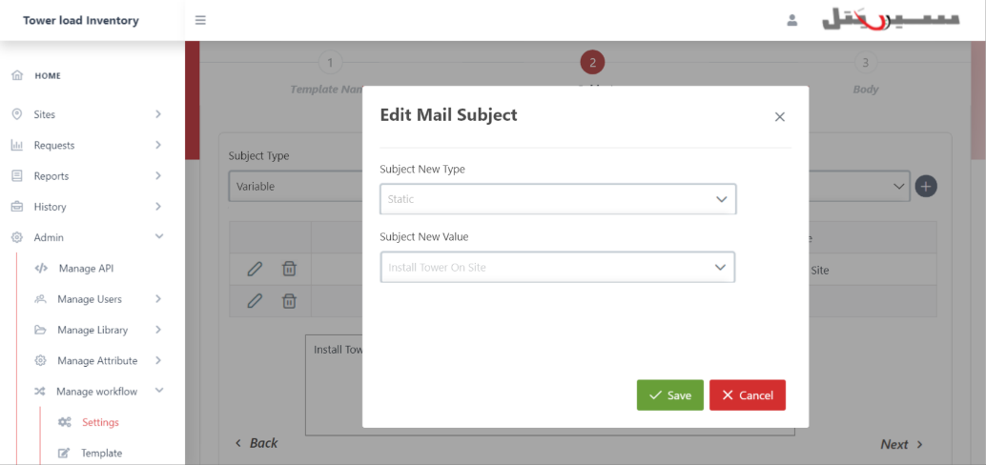

Figure 1-Edit Mail Subject.

#### Delete Content Use Case

Note: The user will be able to Delete the contents of this template

Note: Delete content body will be the same of delete content subject.

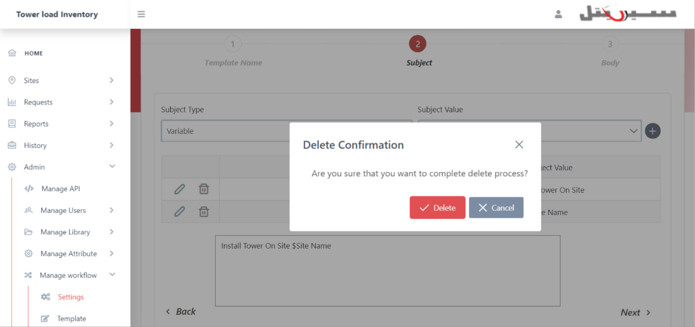

Figure 1-Delete Mail Subject.

#### 5.Edite Mail Template Use Case

Note: The user will be able to modify the information of this template

#### Delete Mail Template Use Case

Note: The user will be able to Delete the mail template

### **My Requests Use Cases**

#### View My Requests Use Case

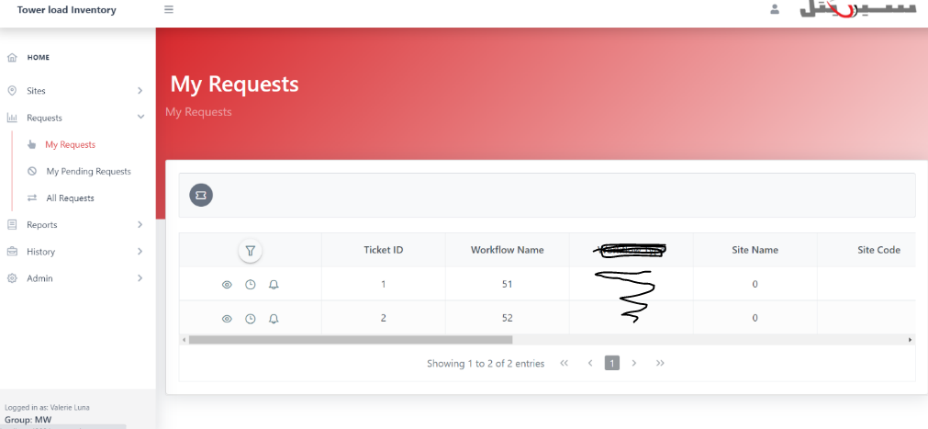

#### Open Tickets on Multi (sites, regions or areas) Use Case

User wants to open tickets on multi (sites, regions, or areas).

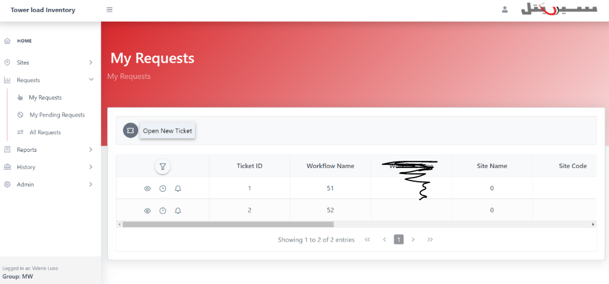

Figure 36-Button of Open Ticket.

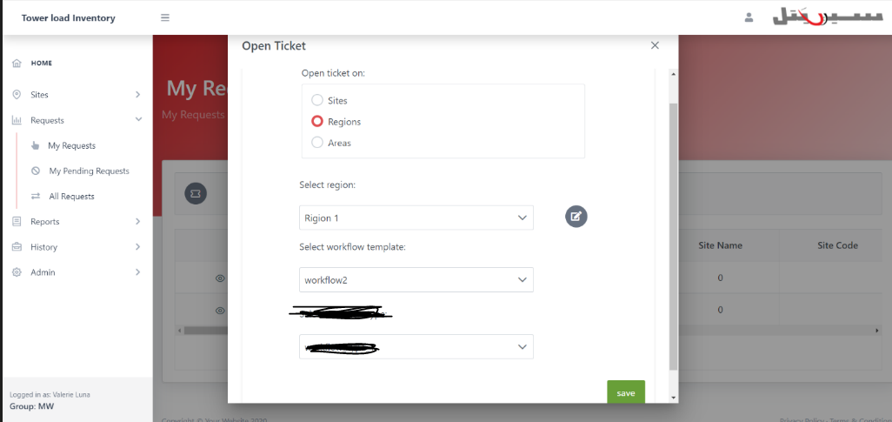

Figure 37-Open Ticket on Multi Regions.

### **My Pending Requests Use Cases**

#### View My Pending Requests Use Case

User wants to display all requests which are pending and waiting to be executed by them.

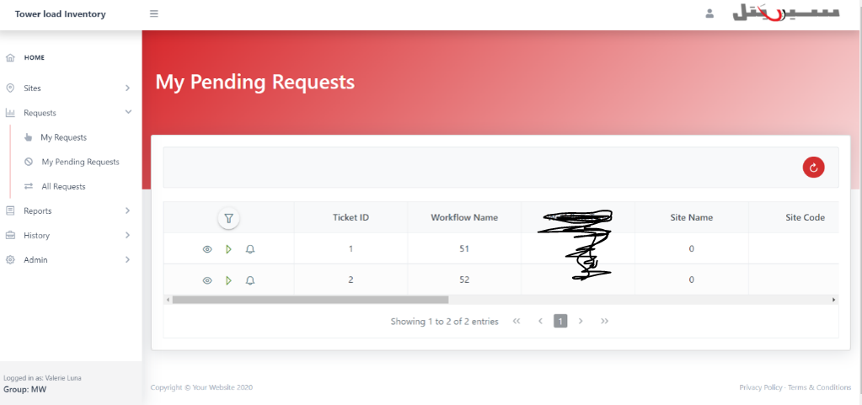

Figure 38-View My Pending Requests Data Table.

#### Execute Pending Action Use Case

User wants to execute the pending action.

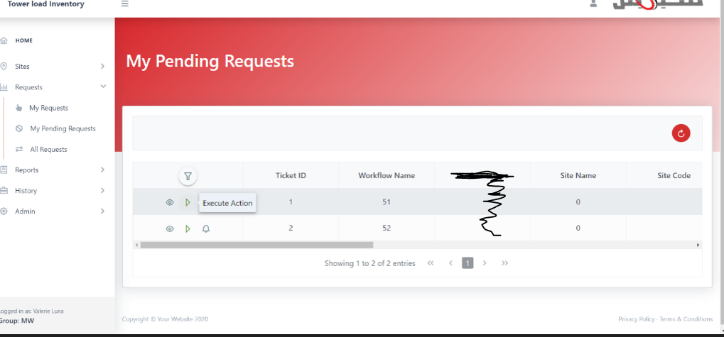

Figure 39-Button of Execute Action.

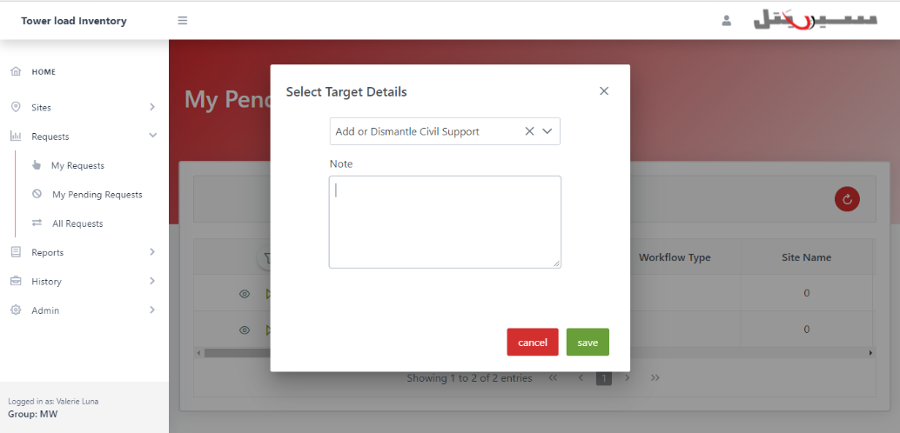

### **All Requests Use Cases**

#### View All Requests Use Case

User wants to display all requests in TLIS.

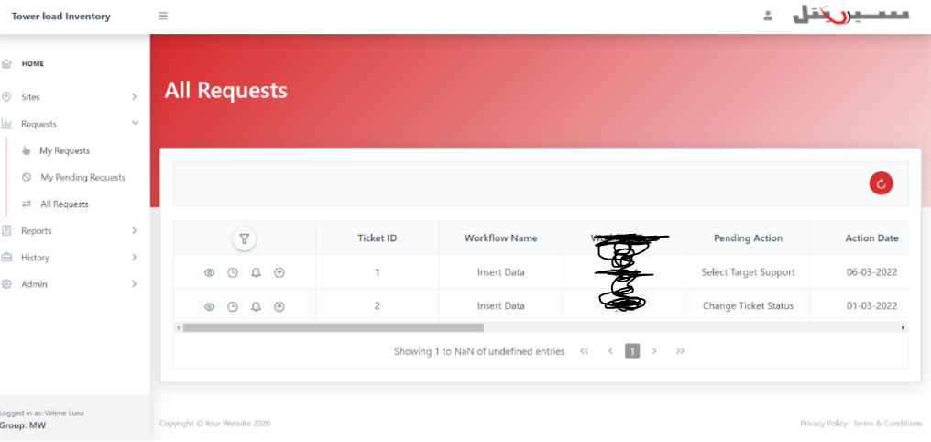

Figure 41-View All Requests Data Table.

### Common Use Cases

#### Filter Displayed Requests Use Case

User wants to filter the displayed requests in the data tables.

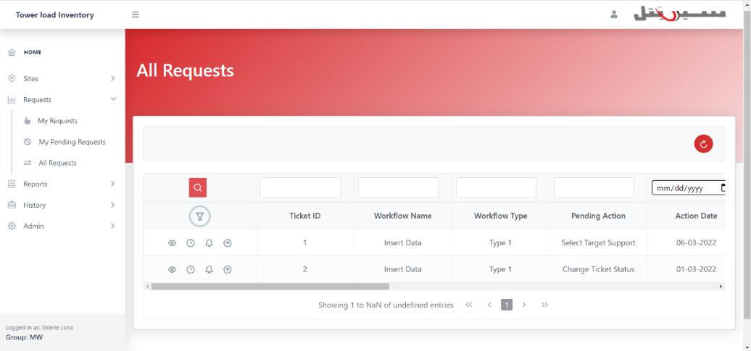

Figure 42-Filter of All Requests.

#### Ticket Details Use Case

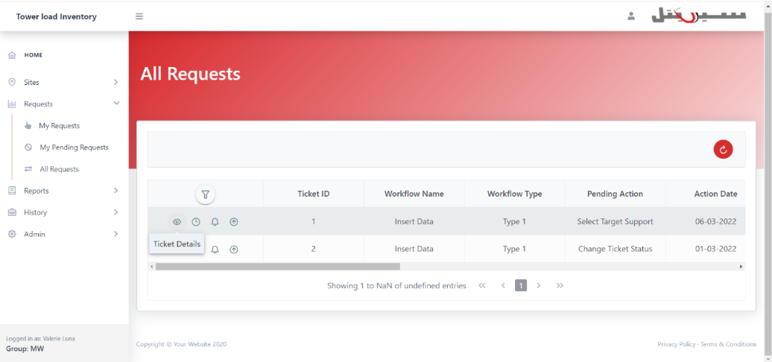

Figure 43-Button of Displaying Ticket Details.

